Exercise No: 5
Date: 04/08/2026

INTRODUCTION TO MAVEN

AIM:
To develop a Java Maven project that reads an mp3 audio file and extracts the artist’s name from the metadata of the mp3 file
PROGRAM:
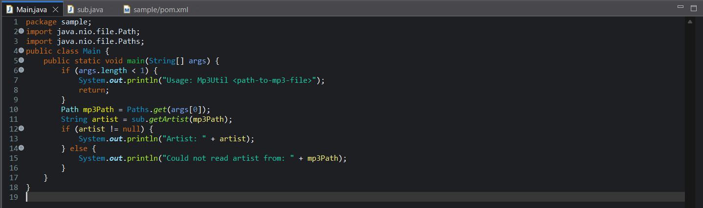
Main.java
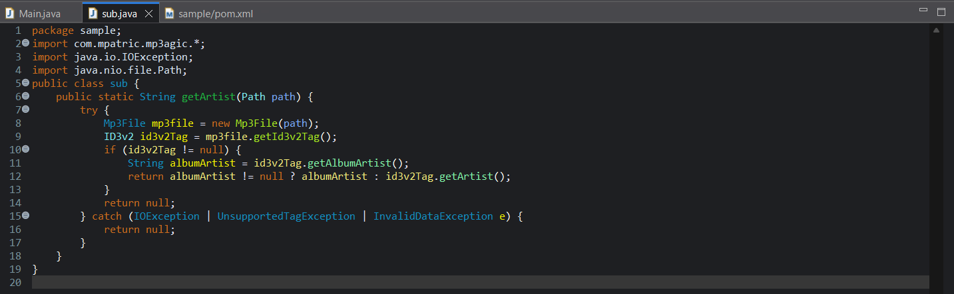
sub.java
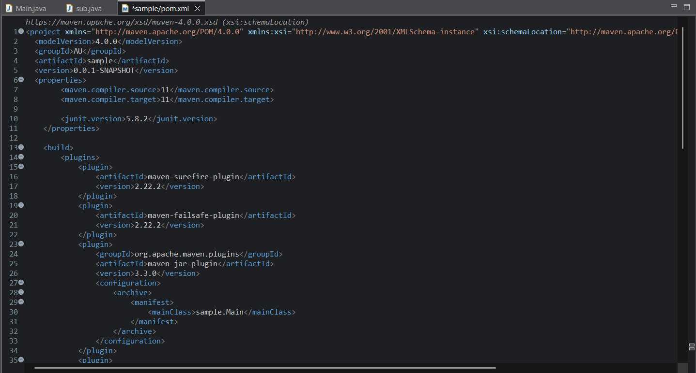
pom.xml
OUTPUT:

